

**WESBURN PINOT NOIR 2012**

*Wesburn was unloved until a few years ago. Planted in 1981, this vineyard, in the far eastern reaches of the Yarra (just before Warburton), sits in the fringe of what many consider marginal viticultural land. It is these sites that truly inspire us and have the potential to make our most exciting wines. The site sits on our beloved siltstone clay soils at the foot of Mount Bride (1000m) which offers cooler nights and mornings. The resultant extension of the ripening period expresses itself by way of far greater tannin depth, high notes and fruit weight. Sometimes walking the fine line reaps rewards.*

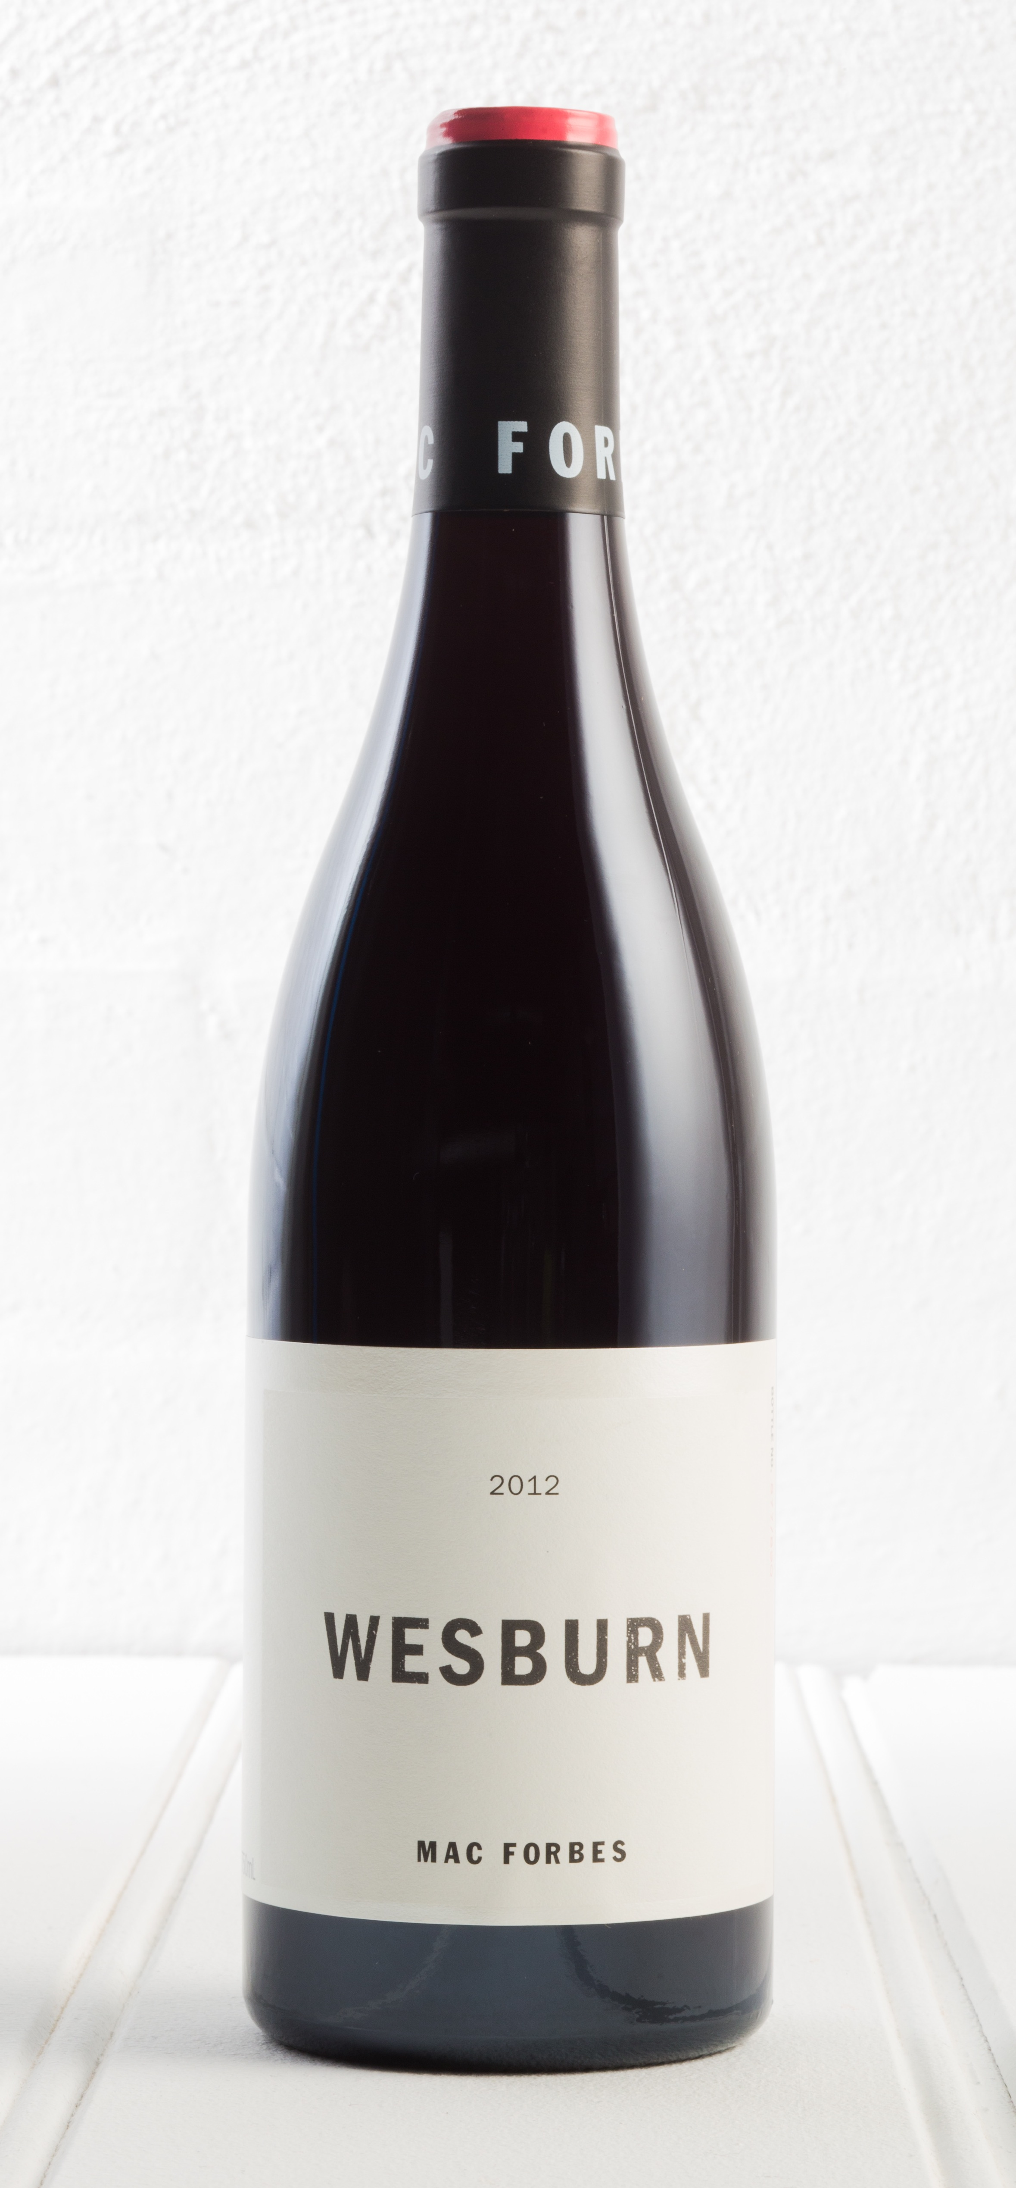

**TASTING NOTES:**

**Appearance**:

Deep garnet/violet with high colour intensity.

**Nose**:

This is the full register of notes from baritone to soprano. Starting with high tone far reaching perfume underpinned with dark dense spicy fruit. Challenging in an exciting way.

**Palate**:

Parma violets meld with elements of spicy dark cherry and chocolate. The wine offers a seamless transition over the palate with fruit, acidity and tannin perfectly weighted.

‘Tall dark and handsome with broad shoulders, a 5 o’clock shadow and wearing ballet tights….mmmmmm.’ Amanda Lerch

**MAP OF THE LOWER & UPPER YARRA VALLEY**

**MF small map_revised_2013_1**

**WINE ANALYSIS**

Alc/Vol: 13.5%

Acidity: 6.6g/l

pH: 3.47

**VINEYARD**

Town: Wesburn

Region: Yarra Valley

Planted: 1981

Area: 0.5Ha

Clone: MV6

Aspect: East North East

Soils: Yellow Grey Clay over mudstone

Altitude: 180m

**VINTAGE CONDITIONS**

The growing season for the 2012 vintage began with a promising start, with good reserves of soil moisture from soaking rains towards the end of 2011.

Early season growth was strong, with bud burst coinciding with warm spring weather and higher levels of rainfall.

The result was good early vine growth and flowering however, it was a challenge to manage the vigorous canopy.

By Christmas the weather became more settled. Veraison was swift and the ensuing harvest commenced with very good weather conditions overall.

The Wesburn vineyard was picked by hand on the 25th February 2012.

**WINEMAKING**

Fruit: 10% whole bunch, partially de-stemmed, portion foot stomped

Fermentation: hand plunged, open fermenter

Time on Skins: 18 days

Maturation: 11 months in new and old oak

Yeast: indigenous

Filtration: none

Fining: none

Bottled: Feb 5, 2013

Released September 2013

[www.macforbes.com](http://www.macforbes.com)